CALCULUS

GENERAL NOTES:
- This document is NOT meant for an initial introduction to the art of calculus. While I will give some explanations regarding why certain things work, it will not give you an intuitive understanding of the topic.
- Any time there is a blue “or”, it means that it is not part of the equation. Rather, it is used to show different notations or representations of formulae.
- Assume that if no explicit variable is stated as in $f(y)$, $f$ is implicitly $f(x)$.
- Curly braces {} are used either as a placeholder, e.g. $f\left(x\right)=\left\{something\right\}+g(x)$, or as a formatting note, e.g. $n\{roman numerals\}$.
- In this document, Lagrange calculus notation and Leibniz notation will be most primarily used, while Newton’s notation will not be used as much, as it limits the flexibility of calculus notation.

DIFFFERENTIATION:

BRIEF INTRODUCTION:
- Differentiation is the way in which we find the “instantaneous rate of change” of a function. On a graph this is usually the gradient or slope of the line. It is quite easy to find the slope of a straight, linear function. We just use the formula $slope=\frac{rise}{run}$ or more formally, $m=\frac{{y_{2}-y}_{1}}{x_{2}-x_{1}}$. It doesn’t matter how far apart these points are, the slope remains the same.
- However, it is a completely different story with non-linear functions. Take for example the function $f\left(x\right)=x^{2}$. Let’s try calculating the slope by picking the points (0, 0) and (1, 1), which both lie on the graph of $x^{2}$. Taking the slope: $m=\frac{1-0}{1-0}=1$. Now what happens if we choose the points (2, 4) and (3, 9), both of which also lie on the graph of $x^{2}$? Well, the slope become $m=\frac{9-4}{3-2}=5$, which is different to our previous calculation. That is because the slope is not constant across the function.
- So, what is the slope at $x=1$, for example? Well, we can first take the average slope between 1 and 2, which ends up being 3. Okay, now what if we calculate the average slope between 1 and 1.5? It becomes 2.5. Now repeat this process with smaller and smaller x differences: 1 and 1.1 yields 2.1, 1 and 1.01 yields 2.01, etc.

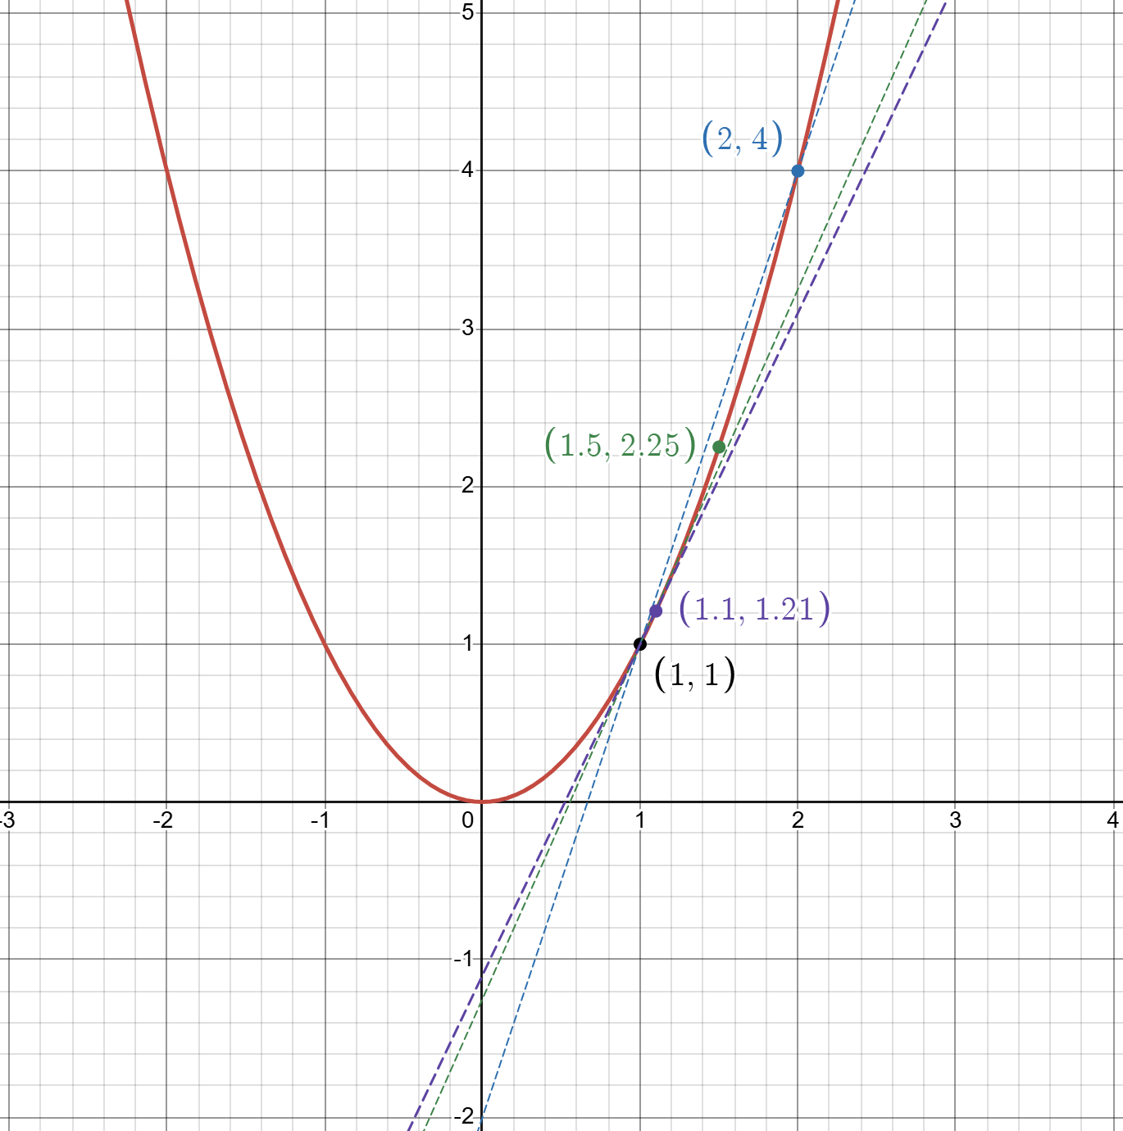

- What we end up seeing is that the slope “approaches” the value of 2 as we make the interval smaller and smaller. This is what is called the “limit”, and it is a very useful tool in many areas of mathematics, especially calculus.
- We will talk about the limit in due time. In the meanwhile, there are several rules that can be used to calculate the slope of a function. Instead of outputting a constant, it will output a function that relates any x value of the function to its corresponding slope.

NOTATION:
Leibniz:
- First derivative: $\frac{d}{dx}f\left(x\right) or \frac{df}{dx}\left(x\right)$
- Derivative of y with respect to x: $\frac{dy}{dx}f(x)$
- Higher derivatives: $\frac{d^{2}f}{dx^{2}}\left(x\right)→\frac{d^{n}f}{dn^{2}}(x)$ (single variable) or $\frac{d}{dx}\frac{d}{dy}\frac{d}{dz}f(x, y, z)$(multi-variable)
Lagrange:
- First derivative: $f^{'}\left(x\right)$
- Higher derivatives: $f^{''}\left(x\right)→f^{'''}\left(x\right)→f^{iv}\left(x\right)→f^{n\{roman numerals\}}(x)$
Newton:
- First derivative: $\dot{x}$
- Higher derivatives: $\ddot{x}→\overset{⃛}{x}…$
- Note: Usually used when differentiation is with respect to time

LAWS OF DIFFERENTIATION:
Constant & Constant Multiple Rules:
$$\frac{d}{dx}\left(c\right)=0 or c^{'}=0$$
$$\frac{d}{dx}c∙f\left(x\right)=c∙\frac{d}{dx}f\left(x\right) or {\left(c∙f\left(x\right)\right)}^{'}=c∙f'(x)$$
Power Rule:
$$\frac{d}{dx}\left(x^{n}\right)=nx^{n-1} or {\left(x^{n}\right)}^{'}=nx^{n-1}$$
Sum & Difference Rules:
$$\frac{d}{dx}\left(f\left(x\right)±g\left(x\right)\right)=\frac{d}{dx}f\left(x\right)±\frac{d}{dx}g\left(x\right) or {\left(f\left(x\right)±g\left(x\right)\right)}^{'}=f^{'}\left(x\right)±g'(x)$$
Product Rule:
$$\frac{d}{dx}\left(f\left(x\right)∙g\left(x\right)\right)=\frac{d}{dx}f\left(x\right)∙g\left(x\right)+\frac{d}{dx}g\left(x\right)∙f\left(x\right) or {\left(f\left(x\right)∙g\left(x\right)\right)}^{'}=f^{'}g+g^{'}f$$
Quotient Rule:
$$\frac{d}{dx}\left(\frac{f\left(x\right)}{g\left(x\right)}\right)= \frac{\frac{d}{dx}f\left(x\right)∙g\left(x\right)-\frac{d}{dx}g(x)∙f(x)}{{\left(g\left(x\right)\right)}^{2}} or {\left(\frac{f\left(x\right)}{g\left(x\right)}\right)}^{'}=\frac{f^{'}g-g'f}{g^{2}}$$
Chain Rule:
$$\frac{d}{dx}\left(f\left(g\left(x\right)\right)\right)=\frac{d}{dx}f\left(g\left(x\right)\right)∙\frac{d}{dx}g\left(x\right) or {\left(f\left(g\left(x\right)\right)\right)}^{'}=f'(g\left(x\right))∙g'(x)$$
Trigonometric Functions:
Function | Derivative | Function | Derivative
$$\sin{x}$$ | $$\cos{x}$$ | $$\arcsin{x}$$ | $$\frac{1}{\sqrt{1-x^{2}}}$$
$$\cos{x}$$ | $$-\sin{x}$$ | $$\arccos{x}$$ | $$-\frac{1}{\sqrt{1-x^{2}}}$$
$$\tan{x}$$ | $$\sec^{2}{x}$$ | $$\arctan{x}$$ | $$\frac{1}{1+x^{2}}$$
$$\cot{x}$$ | $$-\csc^{2}{x}$$ | $$\operatorname{arccot}{x}$$ | $$-\frac{1}{1+x^{2}}$$
$$\sec{x}$$ | $$\sec{x ∙\tan{x}}$$ | $$\operatorname{arcsec}{x}$$ | $$\frac{1}{\left|x\right|\sqrt{1-x^{2}}}$$
$$\csc{x}$$ | $$-\csc{x ∙\cot{x}}$$ | $$\operatorname{arccsc}{x}$$ | $$-\frac{1}{\left|x\right|\sqrt{1-x^{2}}}$$

Exponentiation and Logarithmic Functions:
Function | Derivative | Function | Derivative
$$\ln{x}$$ | $$\frac{1}{x}$$ | $$\log_{b}(x)$$ | $$\frac{1}{x\ln{b}}$$
$$ln⁡(f\left(x\right))$$ | $$\frac{f^{'}\left(x\right)}{f\left(x\right)}$$ | $$\log_{b}(f\left(x\right))$$ | $$\frac{f^{'}\left(x\right)}{f\left(x\right)\ln{b}}$$
$$e^{x}$$ | $$e^{x}$$ | $$a^{x}$$ | $$a^{x}\ln{a}$$
$$e^{f\left(x\right)}$$ | $$f'(x)∙e^{f\left(x\right)}$$ | $$a^{f\left(x\right)}$$ | $$f'(x)∙a^{f\left(x\right)}∙\ln{a}$$
$$x^{x}$$ | $$x^{x}(1+\ln{x)}$$ | $$a^{x^{n}}$$ | $$a^{x^{n}}∙\ln{a∙nx^{n-1}}$$

DIFFERENTIATION EXAMPLE:

$$SOLVE: \frac{d}{dx}(e^{2x}+3sin⁡(\ln{x}))$$
$$Using the sum rule:\frac{d}{dx}\left(e^{2x}+3\sin\left(\ln{x}\right)\right)=\frac{d}{dx}e^{2x}+\frac{d}{dx}3sin⁡(\ln{x})$$
$$\frac{d}{dx}e^{2x}=2e^{2x} \left(As seen in table of exponentiation and logarithms\right)$$
$$Using the constant multiple rule:\frac{d}{dx}e^{2x}=3\frac{d}{dx}sin⁡(\ln{x)}$$
$$Using the chain rule:\frac{d}{dx}sin⁡(\ln{x)}=cos⁡(\ln{x)+\frac{1}{x}}$$
$$Putting it all together:\frac{d}{dx}(e^{2x}+3\sin\left(\ln{x)}\right)=2e^{2x}+3[\sin\left(\ln{x}\right)+\frac{1}{x}]$$

IMPLICIT DIFFERENTIATION:
- Use Implicit Differentiation when it is impractical to rearrange the equation such that the subject of the function is $y$ or $f(x)$.
- When this occurs, differentiate both sides of the equation with respect to $x$ or the appropriate variable, treating $y$ as a function of $x$ and using the chain rule.

$$Differentiate:x^{2}+y^{2}=25$$

$$\frac{d}{dx}\left(x^{2}+y^{2}\right)=\frac{d}{dx}25$$
$$Using constant rule:\frac{d}{dx}25=0$$
$$Using sum rule:\frac{d}{dx}\left(x^{2}+y^{2}\right)=\frac{d}{dx}x^{2}+\frac{d}{dx}\left(y^{2}\right)$$
$$Using the power rule:\frac{d}{dx}x^{2}=2x$$
$$We are think of y as f\left(x\right), since it is a function: \frac{d}{dx}y^{2}=\frac{d}{dx}f{\left(x\right)}^{2}$$
$$\frac{d}{dx}f{\left(x\right)}^{2}=2f\left(x\right)∙\frac{d}{dx}f(x)$$
$$Thus:2x+2y∙\frac{d}{dx}y=0$$
$$2y∙\frac{d}{dx}y=-2x→\frac{d}{dx}y=-\frac{2x}{2y}$$

$$\frac{d}{dx}f\left(x\right)=-\frac{x}{y}$$

POINTS OF INFLECTION: Maxima and Minima:
- A point of inflection is a point in a graph where the function “changes direction”. For example, the graph $x^{2}$ initially decreases as you go through the domain of negative numbers. Then at the point 0, the function “changes direction” and begins to increase towards infinity.
- Some functions, such as $\sin{x}$ and $-x^{2}$ have a global maximum. That is the largest point that the function can map to *. Other functions, like $x^{3}-2x$ only have a local maximum - that is a point where the graph “changes direction”, creating a point of inflection, but then “changes direction” again, heading towards positive infinity. Thus, it is not the greatest possible value, but it is greater than the surrounding points on the graph.
* The graph $-x^{2}$ of course only has a maximum if the domain is real numbers.

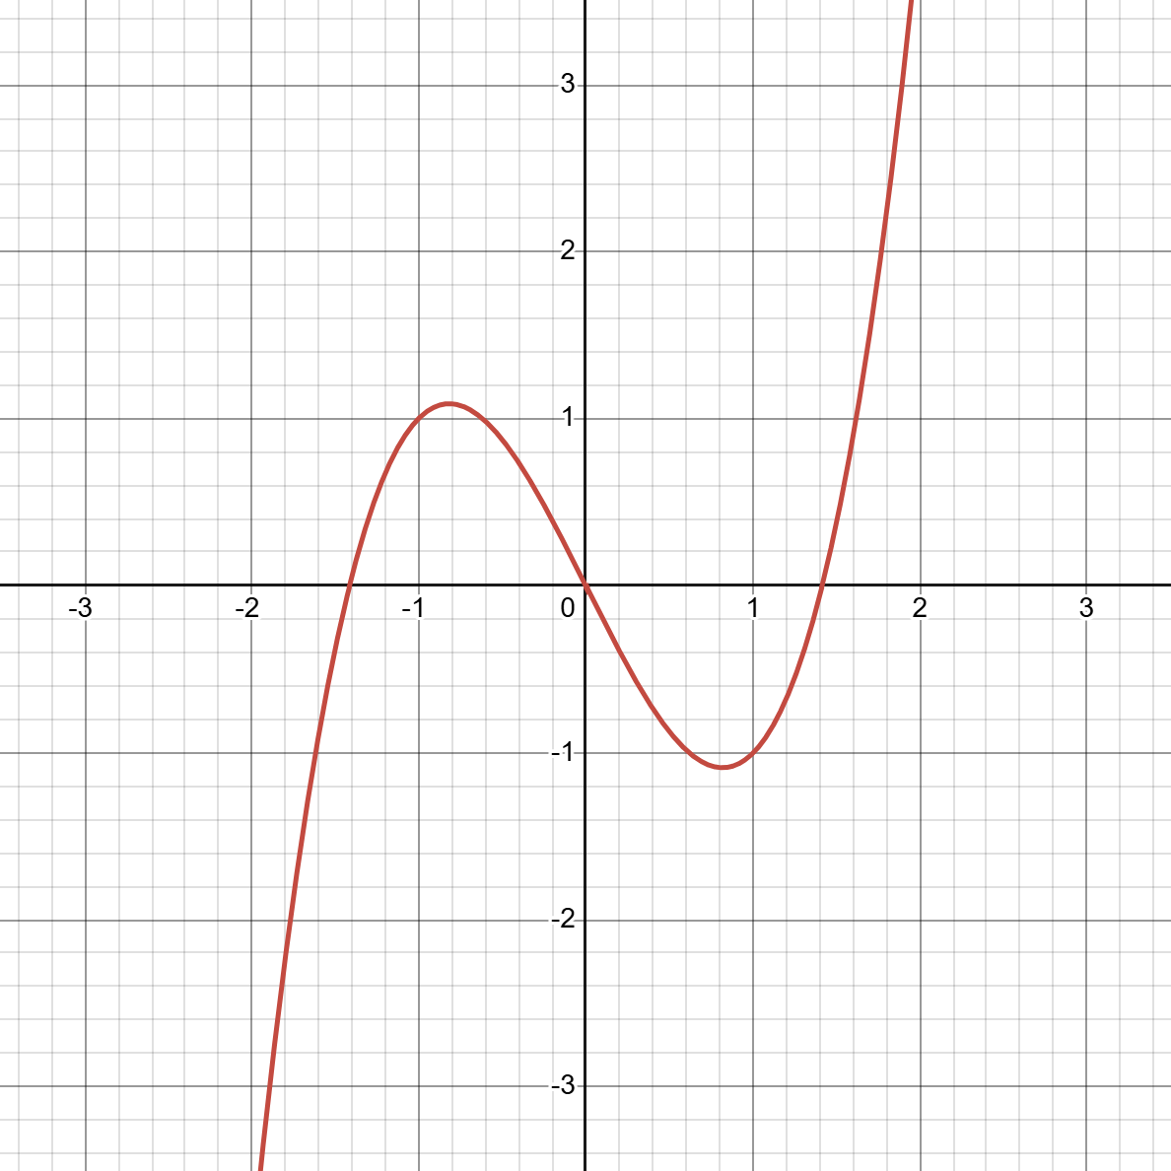
Points of Inflection
Local Maximum
Local Minimum

- Similarly, a function may have a global or local function minimum. A global minimum is the smallest possible point the function can map to. A local minimum is a point where the surrounding points are all greater than it.
- A function can only ever have 1 global maximum or minimum, but it is possible that it might appear at multiple points in the graph.
- For cosine and sin, the global maximum is 1 and the global minimum is -1: No input of $\sin{x}$ or $\cos{x}$ can reach a value greater than 1 or less than -1.

- You will observe that whenever there is an inflection point, the slope of the graph looks flat. Thus, in order to find the inflection points of a function, find the points of the function where the derivative is equal to zero, then use the second derivative test to see if the point is a maximum or minimum. If it yields 0, then the second derivative test is inconclusive.

- EXAMPLE:

$$f\left(x\right)=x^{3}-2x$$
$$\frac{d}{dx}f\left(x\right)=3x^{2}-2 (Due to the difference and power rules)$$
$$Set the derivative to 0: 3x^{2}-2=0$$
$$3x^{2}=2→ x^{2}=\frac{2}{3}$$
$$x=±\sqrt{\frac{2}{3}}$$
$$y_{1}={\left(\sqrt{\frac{2}{3}}\right)}^{3}-2\left(\sqrt{\frac{2}{3}}\right)≈-1.0887…$$
$$y_{2}={\left(-\sqrt{\frac{2}{3}}\right)}^{3}-2\left(-\sqrt{\frac{2}{3}}\right)≈1.0887…$$
$$\frac{d^{2}}{dx^{2}}\left(x^{3}-2x\right)=\frac{d}{dx}\left(3x^{2}-2\right)=6x$$
$$6∙\sqrt{\frac{2}{3}} >0 ∴ x_{1} is a minimum$$
$$6∙-\sqrt{\frac{2}{3}} <0 ∴ x_{2} is a maximum$$

- This seems to align with our observations of the graph on the previous page. Thus, we can say that the local maximum of the function $f\left(x\right)=x^{3}-2x$ is at $x=-\sqrt{\frac{2}{3}}$, and the minimum is at $x=\sqrt{\frac{2}{3}}$.

RELATED RATES PROBLEMS:
- Related rates problems are a common application of differentiation. It tells you the rate at which one value is growing as you increase another. For example, consider the problem below:
- The radius of a sphere is expanding at a rate of 1cm/s. At time t=0, the sphere has a radius of 0. After 10 seconds, what is the rate at which the volume of the sphere is increasing?
$$Volume of sphere formula:V=\frac{4}{3}πr^{3}$$
$$So\frac{dV}{dr}is the rate of change of the volume with respect to the radius.$$
$$\frac{dV}{dr}=\frac{d}{dr}\left(\frac{4}{3}πr^{3}\right)=\frac{4}{3}π∙\frac{d}{dr}r^{3}=4πr^{2} (constant multiple \& power rules)$$
$$\frac{dV}{dr}=4πr^{2}$$
$$After 10 seconds, r=10cm$$
$$\frac{dV}{dr} at radius 10=4π{\left(10\right)}^{2}≈1256.64 cm^{3}/s$$

OPTIMISATION PROBLEMS:
- Another useful application of derivatives is in optimisation problems, where you are trying to maximise one value given some parameters about another value. To solve these, use maxima and minima. For example, consider the problem:
- A farmer is situated by a straight river and has 1km of fencing. He must build a rectangular paddock for livestock and is trying to maximise the amount of area in his enclosure. He may use the river as one of the sides of the enclosure. What is the optimal fence design?
$$Total length of fencing=1km$$
$$So, l+2w=1, with l as the length of the enclodure and w as the width$$
$$Rearranging, l=1-2w$$
$$A=l∙w$$
$$So, A=w∙\left(1-2w\right)→A=-2w^{2}+w$$

$$Finding the maximum:$$

$$\frac{dA}{dw}=-4w+1$$
$$-4w+1=0→4w=1$$
$$∴maximum w=0.25$$

$$Substituting w back into the original equation:$$
$$l=1-2\left(\frac{1}{4}\right)=0.5$$

$$Thus, the optimal design has a fencing 500m long and 250m wide,$$
$$yielding an enclodure area of 125,000m^{2}.$$

MULTIVARIABLE DERIVATIVES:
- Multivariable calculus is a complex topic, and will not be discussed fully in this document, however I will show some basic examples.
- Multivariable calculus involves partial derivatives instead of normal derivatives, so we must take the partial derivative of the function with respect to a certain variable, by treating the remaining variables as constants

- EXAMPLES:

- Take the partial derivative of Newton’s second law: $F=ma$ with respect to $acceleration$:

$$\frac{∂F}{∂a}=m in the same way that\frac{d}{dx}\left\{constant\right\}∙x=\{constant\}$$

- Take the partial derivative of Newtons law of gravitation with respect to the distance between the bodies’ centres:

$$F=G\frac{m_{1}m_{2}}{r^{2}}$$
$$\frac{∂F}{∂r}=Gm_{1}m_{2}∙\frac{d}{dr}r^{-2}→\frac{∂F}{∂r}=-2G\frac{m_{1}m_{2}}{r^{3}}$$

LIMITS:

LIMIT NOTATION:
- A limit is usually written like this: $\lim_{x→ c}{f(x)}$
- This translates to the limit of the function f(x) as x “approaches” some value c.
- You can also have limits $\lim_{x→ ∞}{f(x)}$
- Sometimes, a limit will yield different results from either end. In this case, we use either $\lim_{x→ a^{-}}$ if the limit is coming from the left side or $\lim_{x→ a^{+}}$ if the limit is coming from the right of $a$.
- Below are methods of evaluating limits. Start at the beginning. If the strategy gives an indeterminate expression like $\frac{∞}{∞}or\frac{0}{0}$, move onto the next strategy. Once something works, go back through the list

EVALUATING LIMITS:

Infinite and Zero Limits:
$$\lim_{x→ ∞}\left(x\right)=∞$$
$$\lim_{x→ ∞}\left(\frac{1}{x}\right)=0$$
$$\lim_{x→ 0^{±}}\left(\frac{1}{x}\right)=±∞$$
Direct Substitution:
$$\lim_{x→ c}{f(x)}=f(c)$$
$$Example: \lim_{x→ 5}\left(\frac{x^{2}-1}{x}\right)=\frac{5^{2}-1}{5}=4.8$$
Sum, difference, product & quotient rules:
$$\lim_{x→ a}\left(f(x)±g(x)\right)=\lim_{x→ a}f(x)±\lim_{x→ a}g(x)$$
$$\lim_{x→ a}\left(f\left(x\right)∙g\left(x\right)\right)=\lim_{x→ a}f(x)∙\lim_{x→ a}g(x)$$
$$\lim_{x→ a}\left(\frac{f\left(x\right)}{g\left(x\right)}\right)=\frac{\lim_{x→ a}f\left(x\right)}{\lim_{x→ a}g\left(x\right)}$$

$$THIS ONLY WORKS WHERE ALL THE INDIVIDUAL LIMITS EXIST!$$
Factorising:
$$Example: \lim_{x→ 2}\left(\frac{x^{2}-4}{x-2}\right)=\lim_{x→ 2}\left(\frac{\left(x-2\right)\left(x+2\right)}{x-2}\right)=\lim_{x→ 2}\left(x+2\right)=4$$
Conjugate multiplication:
$$Example: \lim_{x→ 0}\left(\frac{\sqrt{x+1}-1}{x}\right)=\lim_{x→ 0}\left(\frac{\sqrt{x+1}-1}{x} ∙\frac{\sqrt{x+1}+1}{\sqrt{x+1}+1}\right)$$
$$=\lim_{x→ 0}\left(\frac{x}{x\left(\sqrt{x+1}+1\right)}\right)=\lim_{x→ 0}\left(\frac{1}{\sqrt{x+1}+1}\right)=\frac{1}{2}$$
L’Hôpital’s rule:
$$\lim_{x→ 0}\left(\frac{f\left(x\right)}{g\left(x\right)}\right)=\lim_{x→ 0}\left(\frac{f^{'}\left(x\right)}{g^{'}\left(x\right)}\right)$$
$$Example: \lim_{x→ 0} \left(\frac{\sin{x}}{x}\right)=\lim_{x→ 0} \left(\frac{\cos{x}}{1}\right)=1$$
$$Only works when the limit yields an indeterminate form like\frac{0}{0} or\frac{∞}{∞}$$
$$and the function is differentiable near the point.$$

INTEGRATION:

BRIEF INTRODUCTION:
- Integration and integrals are concerned with figuring out the sum of lots of tiny values. Often this is the area under a curve, but it can also more generally be used when we want to sum over any continuous values, like $\sum{f(x)}$, but for continuous rather than over discrete intervals.
- Integration is generally much harder than differentiation. This is because there is no set “formula” to find the integral of any function. Instead, we must use a combination of techniques to find the integral.
- One basic way to define an integral is a limit of a Riemann Sum. A Riemann sum can be used to approximate the area under a curve by using lots of tiny rectangles, as shown in the image below:
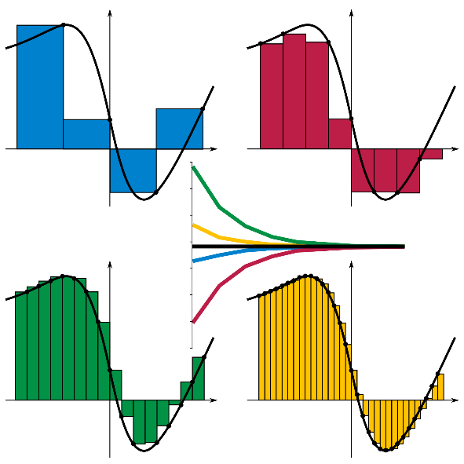

- A Riemann sum can have either its rectangles’ right or left side aligned with the function’s height. It can be defined as this:
$$S=\sum_{i=1}^{n}{f(x_{i})∙∆x}$$
$$where ∆x=x_{i}-x_{i-1} (the width of the rectangle)$$

- An integral gives the signed area under a curve (i.e. if the curve dips below 0, the area will be given as a negative):

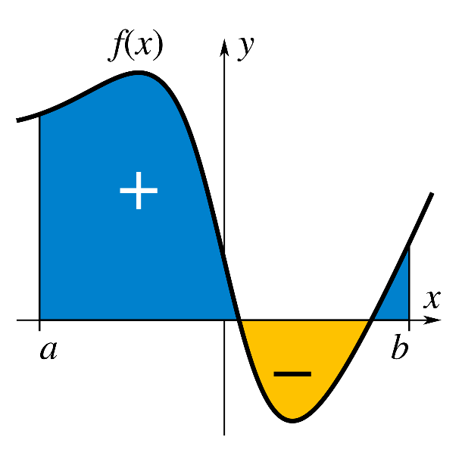
NOTATION:
- Integrals, otherwise known as antiderivatives, are almost always notated using a “long S”, which stands for the Latin word for “sum”. The top and bottom of the integral show the upper and lower bounds of the integral, or the are between the points “a” and “b” in the previous diagram.
- An integral must also have a “dx” symbol at the end, which can be thought of as the width of the tiny rectangles, and it also tells you which function you are integrating with respect to:
$$Integral over x between a and b: \int_{a}^{b}{f\left(x\right) dx}$$
- A double integral can also be defined, similar to how you can have higher order derivatives. There are two main cases: where you integrate over the same variable, like figuring out position from acceleration, and integration over multiple variables, like in finding the volume of a shape:
$$Same variable: \int_{a}^{b}{\left(\int_{c}^{d}{f\left(x\right) dx}\right)dx}$$
$$Different variables: \iint_{R}^{ }{f\left(x, y\right) dx dy}$$
$$The above translates to: \int_{a}^{b}{\left(\int_{c}^{d}{f\left(x, y\right) dx}\right) dy}$$
$$Triple integral: \iiint{f\left(x,y,z\right) dx dy dz}$$
- A “definite” integral between the bounds $a$ and $b$ can be calculated using an “indefinite” integral as follows:
$$\int_{a}^{b}{f\left(x\right) dx}= F\left(b\right)-F(a)$$
$$Where: F\left(x\right)= \int{f\left(x\right) dx}$$
- Every integral must have a “+C” at the end, as constants always get omitted when differentiating a function.

ANALYTIC INTEGRATION:
BASIC RULES:

Constant Multiple Rule:
$$\int{a∙f(x)} dx=a∙\int{f\left(x\right)} dx$$
Sum & Difference Rules:
$$\int{f\left(x\right)}±g\left(x\right) dx=\int{f\left(x\right)} dx±\int{g(x)} dx$$
Power Rule:
$$\int{x^{n}} dx=\frac{x^{n+1}}{n+1}+C$$

Trigonometric Functions:
Function | Integral | Function | Integral
$$\sin{x}$$ | $$-\cos{x+C}$$ | $$\sin^{2}{x}$$ | $$\frac{x}{2}-\frac{\sin\left(2x\right)}{4}+C$$
$$\cos{x}$$ | $$\sin{x+C}$$ | $$\cos^{2}{x}$$ | $$\frac{x}{2}+\frac{\sin\left(2x\right)}{4}+C$$
$$\tan{x}$$ | $$\ln\left(\sec{x}\right)+C$$  $$or-\ln\left(\cos{x}\right)+C$$ | $$\tan^{2}{x}$$ | $$\tan{x-x+C}$$
$$\cot{x}$$ | $$\ln\left(\sin{x}\right)+C$$ | $$\cot^{2}{x}$$ | $$-\cot{x-x+C}$$
$$\sec{x}$$ | $$\ln\left(\sec{x+\tan{x}}\right)+C$$ | $$\sec^{2}{x}$$ | $$\tan{x+C}$$
$$\csc{x}$$ | $$\ln\left(\csc{x-\cot{x}}\right)+C$$ | $$\csc^{2}{x}$$ | $$-\cot{x +C}$$

Double Angle and Squared Trigonometric Identities:
$$\sin\left(2x\right)=2\sin{x\cos{x}}$$
$$\cos\left(2x\right)=2\cos^{2}{x-1}$$
$$\sin^{2}{x=\frac{1-\cos\left(2x\right)}{2}}$$
$$\cos^{2}{x=\frac{1+\cos\left(2x\right)}{2}}$$
$$\tan^{2}{x=\frac{1-\cos\left(2x\right)}{1+cos⁡(2x)}}$$
Exponentiation and Logarithmic Functions:
Function | Integral | Function | Integral
$$\frac{1}{ax+b}$$ | $$\ln\left(ax+b\right)+C$$ | $$\log_{b}(x)$$ | $$\frac{1}{\ln{b}}\left(x\ln{x-x}\right)+C$$
$$a^{x}$$ | $$\frac{1}{\ln{a}}∙a^{x}+C$$  $$a>0,a≠1$$ | $$\log_{b}(f\left(x\right))$$ | $$\frac{f^{'}\left(x\right)}{f\left(x\right)\ln{b}}$$
$$e^{x}$$ | $$e^{x}+C$$ | $$\ln{x}$$ | $$x\ln{x-x+C}$$

INTEGRATION METHODS:

Integration By Substitution:
- Used when an integral contains a function and its derivative (or something close to it). Then you set $u$ to be the function, and $du=\left\{derivative\right\} dx$.
- Next, integrate the function, then substitute the function back for $u$.
- EXAMPLE:
$$\int{8\sin\left(2x+3\right) dx}$$
$$let u=\left(2x+3\right), du=2dx$$
$$\int{8\sin\left(2x+3\right) dx=\int{\sin{u∙4du}}}$$
$$Using the constant multiple rule:\int{\sin{u∙4du}}=4∙\int{\sin{u du}}$$
$$=-4\cos{u+C=-4\cos\left(2x+3\right)+C}$$

Integration by Parts:
- Used when there is a product of two functions.
- Integration by parts is effective when one of the functions gets simpler when differentiated, and one of the functions is easy to integrate.
- Choose $u$ using the LIATE rule, with most preferred at the top and least preferred at the bottom:
  - L – Logarithmic functions, e.g. $\ln{x,\log_{b}{x}}$
  - I – Inverse trigonometric functions, e.g. $\arcsin{x}$
  - A – Algebraic functions, e.g. $x^{2}, 5x$
  - T – Trigonometric functions, e.g. $\sin{x,\cos{x}}$
  - E – Exponentials, e.g. $e^{x}, a^{x}$
- This is the formula for Integration by Parts:
$$\int{u dv=uv-\int{v du}}$$
- EXAMPLE:
$$\int{x^{2}\cos{x dx}}$$
$$let u_{1}=x^{2}, dv_{1}=\cos{x dx}→ du_{1}=2x dx, v_{1}=sin x$$
$$\int{x^{2}\cos{x dx=x^{2}\sin{x}-\int{2x\sin{x dx}}}}$$
$$=x^{2}\sin{x-2∙\int{x\sin{x dx}}}$$
$$let u_{2}=x, dv_{2}=sin x dx→du_{2}=dx, v_{2}=-cos x$$
$$\int{x\sin{x dx=}}-x\cos{x-\int{-\cos{x dx}=-x\cos{x+ sin{x}}}}+C$$
$$∴\int{x^{2}\cos{x dx=x^{2}\sin{x-2\left(x\cos{x+2\sin{x}}\right)=}}}x^{2}\sin{x+2x\cos{x-2\sin{x+C}}}$$

Integration by Trigonometric Substitution:
- Use Integration by Trigonometric Substitution when an integral contains one of the following expressions:
  - $\sqrt{a^{2}-x^{2}}$
  - $\sqrt{a^{2}+x^{2}}$
  - $\sqrt{x^{2}-a^{2}}$
- In these cases, substitute $x$ with the following:
  - $\sqrt{a^{2}-x^{2}}→x=a\sin{θ}$
  - $\sqrt{a^{2}+x^{2}}→x=a\tan{θ}$
  - $\sqrt{x^{2}-a^{2}}→x=a\sec{θ}$
- Then using the following identities, simplify the expression:
  - $\sin^{2}{θ+\cos^{2}{θ=1→\sqrt{a^{2}-{\left(a\sin{θ}\right)}^{2}}}}=\sqrt{1-\sin^{2}{θ}}=\cos{θ}$
  - $1+\tan^{2}{θ=\sec^{2}{θ→}}\sqrt{a^{2}+{(a\tan{θ})}^{2}}=\sqrt{1+\tan^{2}{θ}}=\sec{θ}$
  - $\sec^{2}{θ-1=\tan^{2}{θ→ }}\sqrt{{(a\sec{θ})}^{2}-a^{2}}=\sqrt{\sec^{2}{θ-1}}=\tan{θ}$
- Then set $dx$:
  - $x=a\sin{θ→dx=a\cos{θ dθ}}$
  - $x=a\tan{θ→dx=a\sec^{2}{θ dθ}}$
  - $x=a\sec{θ→dx=a\sec{θ\tan{θ dθ}}}$
- EXAMPLE:
$$\int{\frac{2\sqrt{9-x^{2}}}{5}dx=\frac{2}{5}∙\int{\sqrt{9-x^{2}}}}dx$$
$$let x=3sin θ→dx=3cos θ dθ$$
$$\int{\sqrt{9-x^{2}}}dx=\int{9\cos^{2}{θ} dθ}=9∙\int{\cos^{2}{θ dθ=\frac{9}{2}θ+\frac{9}{4}\sin\left(2θ\right)+C}}$$
$$\int{\frac{2\sqrt{9-x^{2}}}{5}dx}=\frac{18}{10}\left(θ+\frac{\sin\left(2θ\right)}{2}\right)+C$$
$$so since θ=\arcsin\left(\frac{x}{3}\right):$$
$$=\frac{9}{5}\left(arcsin \left(\frac{x}{3}\right)+\frac{1}{2}sin\left(arcsin\left(\frac{x}{3}\right)\right)\right)+C$$

Partial Fraction Decomposition:
- Used to solve rational (polynomial) integrals of the form $\int{\frac{P\left(x\right)}{Q\left(x\right)}dx}$. In this case, $P(x)$ must have a degree that is lower than $Q(x)$.
- Then, split the 2 fractions into smaller, simpler fractions using partial fraction decomposition.
- EXAMPLE:
$$\int{\frac{3x+5}{x^{2}+x-2}dx}$$
$$First, factor the bottom quadratic:x^{2}+x-2=(x-1)(x+2)$$
$$\frac{3x+5}{\left(x-1\right)\left(x+2\right)}=\frac{A}{\left(x-1\right)}+\frac{B}{\left(x+2\right)}$$
$$3x+5=A\left(x+2\right)+B(x-1)$$
$$Now plug in x=1 \left(because it gets rid of one of the terms\right):$$
$$8=3A→A=\frac{8}{3}$$
$$3x+5=\frac{8}{3}\left(x+2\right)+B(x-1)$$
$$Then plug in x=-2:$$
$$-1=-3B→B=\frac{1}{3}$$
$$So, \int{\frac{3x+5}{x^{2}+x-2}dx=\int{\frac{8}{3x-3}dx+\int{\frac{1}{3x+6}}}dx}$$
$$\int{\frac{8}{3x-3}dx=8∙\int{\frac{1}{3x-3}dx=8\ln\left(3x-3\right)+C}}$$
$$\int{\frac{1}{3x+6}dx=\ln\left(3x+6\right)+C}$$
$$∴\int{\frac{3x+5}{x^{2}+x-2}dx=8ln\left(3x-3\right)+ln\left(3x+6\right)+C}$$

Improper Integrals:
- Improper Integrals are a certain type of definite integral where the $b$ value, or the upper bound, is infinity.
- Improper integrals are calculated just like regular definite integrals, except by using a limit for the upper bound.
- EXAMPLE:
$$\int_{2}^{∞}{\frac{2π}{x^{2}} dx}$$
$$\int{\frac{2π}{x^{2}}dx=2π∙\int{\frac{1}{x^{2}}dx=-\frac{2π}{x}+C}}$$
$$\int_{2}^{∞}{\frac{2π}{x^{2}} dx}={\left[-\frac{2π}{x}\right]}_{2}^{∞}=\lim_{x→∞}\left(-\frac{2π}{x}\right)+\frac{π}{2}$$
$$\lim_{x→∞}\left(-\frac{2π}{x}\right)=0$$
$${\left[-\frac{2π}{x}\right]}_{2}^{∞}=\frac{π}{2}$$
$$∴\int_{2}^{∞}{\frac{2π}{x+1}dx=\frac{π}{2}≈1.5708…}$$

NUMERICAL INTEGRATION:
- If no exact, analytical solution can be found, then you can approximate a curve to get a rough answer. Multiple methods exist.

Trapezoidal Rule
- The trapezoidal, or trapezium rule, estimates a curve using 1 or more trapeziums:

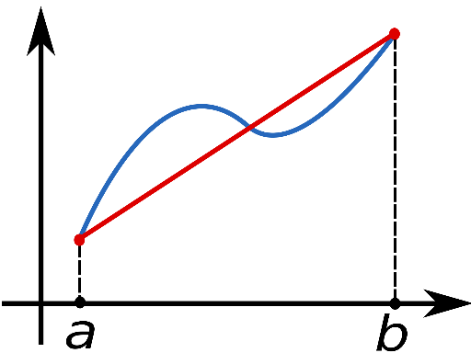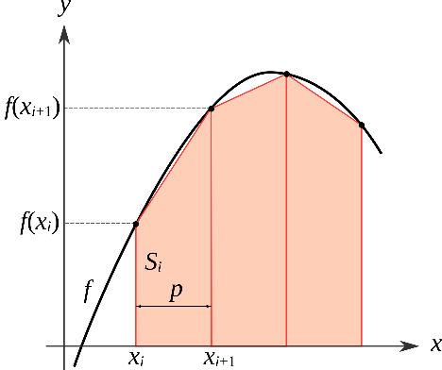

- For a single, very rough calculation, use the formula:
$$\int_{a}^{b}{f(x)≈(b-a)∙\frac{1}{2}\left(f\left(a\right)+f\left(b\right)\right)}$$
- However, this is not very exact. A more precise solution can be found by partitioning the integral into smaller sections, whose areas can be summed up:
$$\int_{a}^{b}{f\left(x\right) dx≈\sum_{k=1}^{N}{\frac{f\left(x_{k-1}\right)+f\left(x_{k}\right)}{2}∆x_{k}}}$$
$$where {\{x}_{k}\} is a partition of \left[a, b\right] such that:$$
$$a=x_{0}<x_{1}<…<x_{N-1}<x_{N}=b$$
$$∆x_{k}=x_{k}-x_{k-1}(the width of the trapezium)$$

Simpson’s Rules:
- There are different variations of Simpson’s rules, but the two most common are Simpson’s 1/3 rule and Simpson’s 3/8 rule.
- The 1/3 rule estimates a definite integral with parabolas, and the 3/8 rule estimates the integral with cubic functions. The 3/8 rule is more complex but is more exact. Both functions can be partitioned as well.

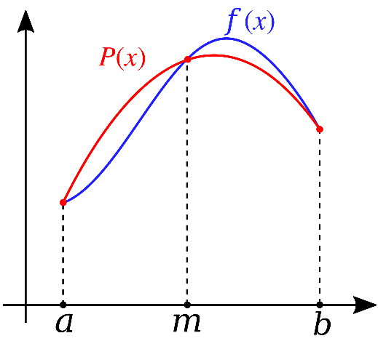

- Simpson’s 1/3 Rule (Single):
$$\int_{a}^{b}{f\left(x\right) dx≈\frac{b-a}{6}}\left[f\left(a\right)+4f\left(\frac{a+b}{2}\right)+f\left(b\right)\right]$$

- Simpson’s 1/3 Rule (Composite):
$$\int_{a}^{b}{f\left(x\right) dx≈\frac{1}{3}h\left[f\left(x_{0}\right)+4\sum_{i=1}^{\frac{n}{2}}{f\left(x_{2i-1}\right)+2\sum_{i=1}^{\frac{n}{2}-1}{f\left(x_{2i}\right)+f\left(x_{n}\right)}}\right]}$$
$$where h=\frac{b-a}{n}and n=number of partitions$$

- Simpson’s 3/8 Rule (Single):
$$\int_{a}^{b}{f\left(x\right) dx≈}\frac{b-a}{8}\left[f\left(a\right)+3f\left(\frac{2a+b}{3}\right)+3f\left(\frac{a+2b}{3}\right)+f\left(b\right)\right]$$

- Simpson’s 3/8 Rule (Composite):
$$\int_{a}^{b}{f\left(x\right) dx≈\frac{3}{8}h\left[f\left(x_{0}\right)+3\sum_{i=1, 3∤i}^{n-1}{f\left(x_{i}\right)+2\sum_{i=1}^{\frac{n}{3}-1}{f\left(x_{3i}\right)+f\left(x_{n}\right)}}\right]}$$
$$where h=\frac{b-a}{n}and n=number of partitions$$
$$a∤b means that a is not a divisor of b (i.e.\frac{a}{b}∉Z)$$

MEAN VALUE OF FUNCTIONS:
- One useful result of integration is the ability to find the mean (average) of a continuous function. To calculate it, use the formula:
$$\overline{f}\left(x\right)= \frac{1}{b-a}\int_{a}^{b}{f\left(x\right) dx}$$

THE THEOREMS OF CALCULUS:

The Fundamental Theorem of Calculus:
- The fundamental theorem of calculus links together integrals and derivatives, roughly speaking, as inverses:
$$\int_{a}^{b}{\left(\frac{d}{dx}f(x)\right)} dx=f\left(b\right)-f(a)$$

Lagrange’s Mean Value Theorem:
- Lagrange’s Mean Value Theorem, or simply the Mean Value Theorem, states that given an arc between two points (i.e. over the interval [a, b]), there exists a point whose derivative is equal to the average slope of the interval [a, b].
- Another way to describe it is that given an arc between the interval [a, b], there exists a tangent to the arc that is parallel to the secant through its endpoints.

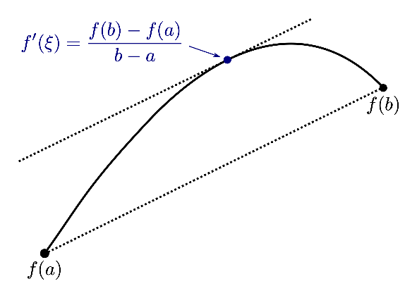

Rolle’s Theorem:
- Rolle’s theorem is a special case of the previously defined “Lagrange’s Mean Value Theorem” and says that if a real function is differentiable (i.e. you can take the derivative), and there are 2 equal values at two distinct points, then the function has some point where the derivative is zero.

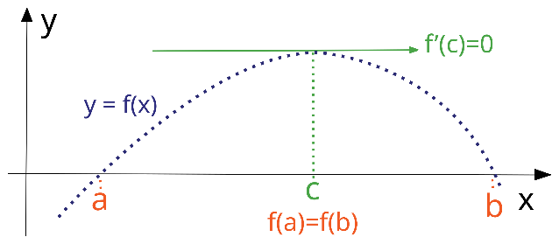

Inverse Function Theorem:
- The Inverse Function Theorem states that if you have a real function that has a derivative near a certain point where the point’s derivative is non-zero, then there exists an inverse function near this point, which is also differentiable.
- This can be represented by the following equation, which basically says that if the derivative is big (the function is changing quickly), then the inverse derivative is small. This makes sense, like how since $y=10x^{2}$ changes quickly, the inverse: $x=\sqrt{\frac{y}{10}}$ is quite small.
$${\left(f^{-1}\right)}^{'}\left(f\left(a\right)\right)=\frac{1}{f'(a)}$$

